   Below steps I have used for exploiting the SQL Injection to get the shell access by using SQLMAP

1. I have used this payload list to brute force the parameters using burp suite, after getting few responses that contain the SQL / Database error in responses, I wanted to exploit it using SQLMAP

<https://github.com/payloadbox/sql-injection-payload-list>

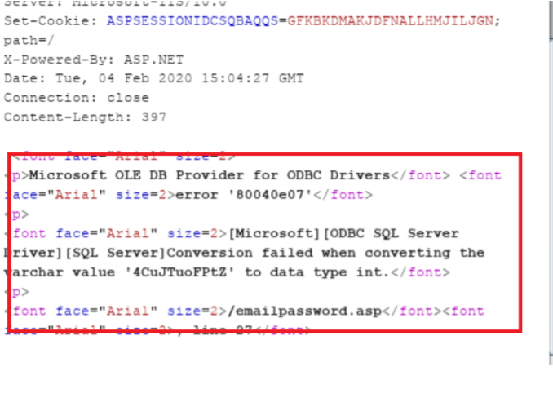

1. Using sqlmap -h to get the list to available options and used the enumeration commands to retrieve few information from the database

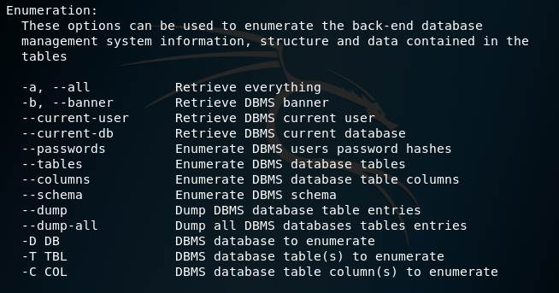

1. Exploit it using the SQLMAP. This a POST request, I have copied it and saved in a file and used the below SQLMAP command to can execute it
2. I have used sqlmap -r request_file.txt -p UserID  –passwords option to get passwords but retrieved passwords are found empty
3. sqlmap -r request_file.txt -p UserID --dump-all to get all database table entries or we add –tables or –columns to get specific information
4. Few user details are retrieved as below

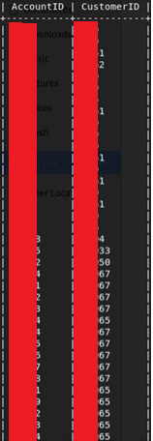

1. Then I have used the –os-shell command to exploit it further

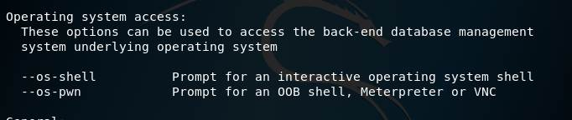

1. Stored procedure xp_cmdshell is found enabled in MSSQL database, so that SQLMAP has executed this procedure to get the windows shell access



1. Finally got the access to the shell and executed the direct windows commands.

